Activity to introduce Accuracy and Precision

- Draw a target on your paper. You will need one target for each member of your group.
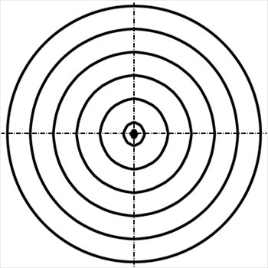
- Using a nerf gun each student will aim at the target and shoot at the target 3-4 times. Use expo markers to mark where the student has hit the target. Each student should be marked by the same color.

- Explain the difference between Accuracy and Precision

Accuracy
Definition:

- Example:

Precision
Definition:

- Example:

4. Discuss the following with the your group. Please put your group answers on the white board and be read to discuss with the entire class:

a.) Which student(s) showed the most precision?
b.) Which student(s) show the most accuracy?
c.) Did any of the students show both accuracy and precision
5. Exit Ticket: You will work on your own to explain which data table is more precise and which is more accurate.

A graduated cylinder is precise. A beaker is not. If you need to know the volume of a liquid you would want to use the graduated cylinder. Three different lab groups used a graduated cylinder to measure out 4.3mL of HCl (Hydrochloric Acid). Below are the data for each group.

Group 1 | Group 2 | Group 3
4.12 | 4.32 | 4.35
4.11 | 4.28 | 4.52
4.13 | 4.37 | 4.21
4.11 | 4.36 | 4.44
4.13 | 4.31 | 4.60

