Learning objective: ___________________________________________
___________________________________________________________________________.
Do Now:
- What is the daily high temperature? _______________

- What is the overnight low temperature? __________________

- Write 2 sentences to tell someone how the weather will be on this day:

Class Notes: Clouds
Cloud = __________________________________________________________________
___________________________________________________________________________.

3 Main Types of Clouds (draw them in over the scene):

1. _________________________

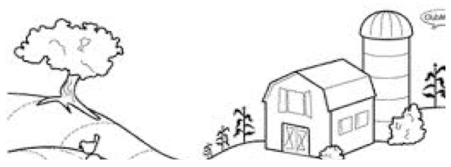
2. ___________________________________

3. ___________________________________

