Science Homework – 3 Main Cloud Types
Always use your class notes to help you!
1. What type of cloud is show below? ____________________________
List at least 4 adjectives to describe this type of cloud:

______________________
______________________
______________________
______________________

2. What type of cloud is show below? ____________________________
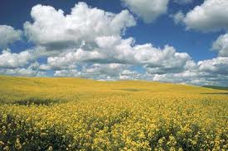
List at least 4 adjectives to describe this type of cloud:

______________________
______________________
______________________
______________________

3. What type of cloud is show below? ____________________________
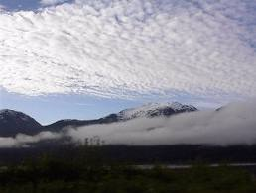
List at least 4 adjectives to describe this type of cloud:

______________________
______________________
______________________
______________________

