Learning objective: ___________________________________________
___________________________________________________________________________.
Do Now:

Class Notes: How Clouds Form
Changes in weather all start from one thing…..

Uneven _________________ of the Earth by the ________ causes different
________________________________________.

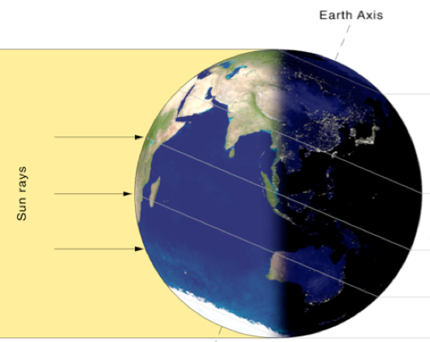

Where is air the hottest?
__________________________

Quick Review of Phase Changes:

1. When a substance is heated, its particles move __________________.
2. When a substance is heated, its particles......

spread out OR move together

The same thing happens _______________________________________________.
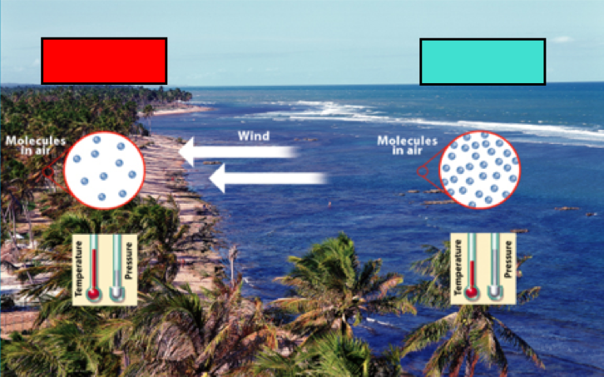

Which type of air do you think is lighter?
____________________
Why?

What do you think happens when warm air meets cold air? Why?




