**Learning objective: ___________________________________________**

**___________________________________________________________________________.**

**Do Now:**

**Class Notes: Atmosphere**

1. Atmosphere = ________________________________________________________

___________________________________________________________________________.

2. But, protects Earth from what?

Protection from…

...too much ______________________________________________________________.

...being _________________________________________ (keeps in heat).

...from ___________________________________________.



3. Gases in the Atmosphere

1. _____________________ - _________%
2. _____________________ - _________%
3. __________________________________

_________%

**Guided Practice:**

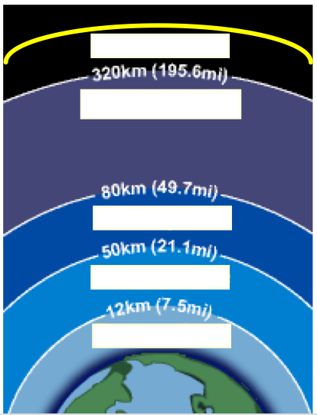

5 Layers of Earth’s Atmosphere

